**2020 ESS 132: Terrestrial Hydrology Homework 2**

You are welcome to work together on this homework to understand the concepts but your answers and workings must be in your own words. Group answers are not acceptable. Your completed homework is due by 11.59p.m. on Friday of Week 4 (Oct 30th). You can submit either as a .doc, .pdf, or you can take pictures and submit as .jpg or .png if you prefer to complete your homework on paper.

**Part A: Precipitation (21)**

1. Explain 2 reasons that precipitation gauges can give inaccurate measurements and for each give a design feature that attempts to minimize any potential errors that may result. (4)

1. Raindrops can get stuck on the sides of rain gauges and can evaporate off instead of falling in, resulting in an underestimation of precipitation. To correct for that, the opening of the rain gauge can be made small to minimize evaporation loss.

2. Collected rain might evaporate from waiting too long to record data. A design feature that can correct this is to design a recording rain gauge.

1. The main challenge of using rain gauges is that they only represent point measurements so we have to find ways of averaging over the entire watershed area.

Rain gauge readings are: A = 17.3 mm, B = 18.6 mm, C = 20.1 mm, D = 22.7 mm, E = 21.3 mm, F = 19.8 mm, G = 18.1 mm, H = 16.9 mm.

Calculate the equivalent uniform depth (EUD) of precipitation for the watershed in the figures on the next page below using:

* 1. the arithmetic mean (1)

**EUD = 19.35 mm**

* 1. Thiessen polygons (please show all of your construction lines) (4)

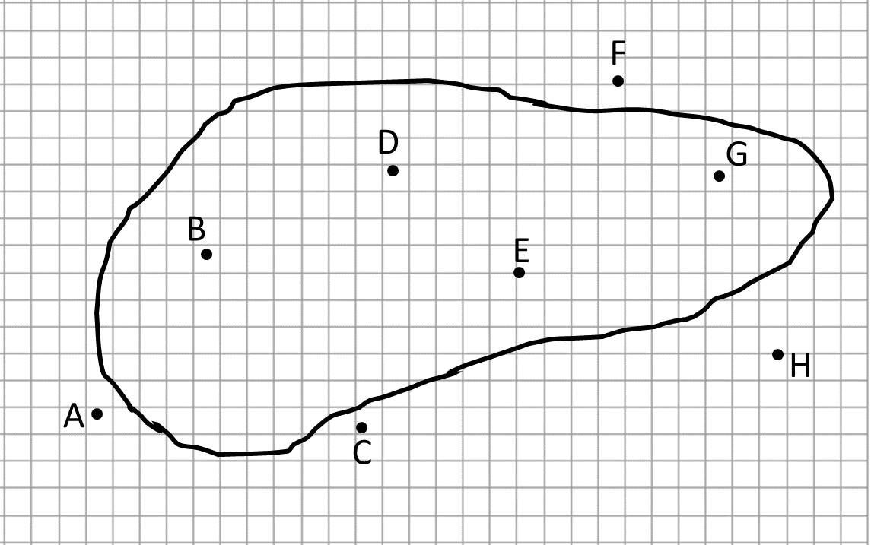

To avoid having to count up all the squares on the graph above, use the table below with some sample numbers for this watershed to calculate the EUD. (4)



**EUD = 19.65 mm**

* + 1. the isohyetal method (drawing isohyets at 1mm intervals) (4)



19

18

17

22

21

20

19

18

To avoid having to count up all the squares on the graph above, use the table below with some sample numbers for this watershed to calculate the EUD. (4)



$$EUD=\left(\frac{70 {km}^{2}}{1565 {km}^{2}}×\frac{17 mm}{1}\right)+\left(\frac{245 {km}^{2}}{1565 {km}^{2}}×\frac{17 mm+18 mm}{2}\right)+\left(\frac{300 {km}^{2}}{1565 {km}^{2}}×\frac{18 mm+19 mm}{2}\right)+\left(\frac{240 {km}^{2}}{1565 {km}^{2}}×\frac{19 mm+20 mm}{2}\right)+\left(\frac{335 {km}^{2}}{1565 {km}^{2}}×\frac{20 mm+21 mm}{2}\right)+\left(\frac{250 {km}^{2}}{1565 {km}^{2}}×\frac{21 mm+22 mm}{2}\right)+\left(\frac{125 {km}^{2}}{1565 {km}^{2}}×\frac{22 mm}{1}\right)$$

**EUD = 19.62 mm**

**Part B – Snowmelt (9)**

1. For this problem we are going to look at the Tioga Pass snow data from the Mono Lake region. Use the following link to find data to complete the table below and answer the following questions. In the data, the snow water equivalent is labeled as “water content (W.C.)”. Because there are no measurements for this year yet, we will compare the relatively wet year of 2019 with the most recent year of 2020! (1)

California snow courses: <http://cdec.water.ca.gov/misc/SnowCourses.html>

4/2019 Snow water equivalent (inches) = 43

4/2020 Snow water equivalent (inches) = 13.5

1. Now let’s estimate how long it will take for the snow to melt in 2020 vs 2019. The net energy flux to snowpack is 10.4 MJ/m2 per day. (Hint: You will need to convert from inches to meters for the snow water equivalent (hm).)
   1. the length of time needed for the warming phase (2)

Qcc = -ciρwhm(Ts-Tm)

Qcc = cold content energy required to raise the average T of snowpack to melting point J/m2

Ci = heat capacity of ice, 2102 J/kgoC

Ts = average T of snowpack, let’s assume this to be -5oC

Tm = melting-point T, 0oC

ρw = density of water = 1000 kg/m3

2019 = 1.10 days 2020 = 0.347 days

* 1. the length of time needed for the ripening phase (2)

Qripe = hwretρwλf

Where Qripe = energy required to complete ripening state, J/m2

λf = latent heat of fusion, 334,000 J/kg

hwret = liquid-water retaining capacity, m

θret = empirically derived for California = 0.04

Reminder: hwret = θreths

2019 = 3.20 days 2020 = 1.40 days

* 1. the length of time needed for output phase (2)

Qout = (hm – hwret)ρwλf

Where Qout = energy required to complete melt, J/m2

2019 = 31.9 days 2020 = 9.61 days

c) We assumed a constant net energy flux to the snowpack of 10.4 MJ/m2 per day. Is this a good assumption? Why? (2)

This is not a reasonable assumption. As the snowpack melts, its albedo is gonna change, resulting in changes in shortwave radiation. During the output phase, the melting process removes heat from the snowpack. Both of these factors change the net energy flux.

**Part C – Evaporation calculations (10)**

a) The nearest location to Tioga Pass where evaporation is measured is the Hetch Hetchy Reservoir. Use the weather data below to calculate the daily evaporation rate using the Meyer and Dunne equations to compare with the measured value. Be careful with units!!

|  |  |  |
| --- | --- | --- |
| Variable | Sept 2020 Avg | Units |
| Air Temperature | 21 | oC |
| Dew pt temperature | 11 | oC |
| Relative Humidity | 57 | % |
| Wind Speed | 2.1 | miles/hr |

Assume the air and water temperature are the same.

1 Pa = 2.9533x10-4 in Hg 100 Pa = 1mb 1mile/h = 1.61 km/h 1 inch = 2.54 cm

i) Meyer Equation (2)

$$vapor pressure=611e^{\frac{17.27T}{T+237.3}}$$

$$actual vapor pressure=611e^{\frac{17.25×11}{11+237.3}}=1313 Pa×\frac{2.9533×{10}^{-4}in Hg}{1 Pa}=0.388 in Hg$$

$$saturation vapor pressure=611e^{\frac{17.27×21}{21+237.3}}=2488 Pa×\frac{2.9533×{10}^{-4}in Hg}{1 Pa}=0.734 in Hg$$

$$E=0.36\left(0.734 in Hg-0.388 in Hg\right)\left(1+\frac{2.1 miles/hour}{10}\right)=0.151\frac{in}{day}×\frac{2.54 cm}{1 in}=0.384 cm/day$$

ii) Dunne Equation (2)

$$RH=100\%×\frac{0.388 in Hg}{0.734 in Hg}=52.78\%$$

$$actual vapor pressure= 1313 Pa×\frac{1 mb}{100 Pa}=13.13 mb$$

$$E=\left(0.013+\left(0.00016×\frac{2.1 mi}{1 hr}×\frac{1.61 km}{1 mi}×\frac{24 hr}{1 day}\right)\right)×13.13 mb×\frac{100-52.78}{100}=0.161 cm/day$$

iii) Which equation is better suited to estimate evaporation for Hetch Hetchy? (ie which is closer to the average September Hetch Hetchy pan evaporation listed on the website below?) (2)

<https://wrcc.dri.edu/Climate/comp_table_show.php?stype=pan_evap_avg>

|  |  |  |
| --- | --- | --- |
| **Method / Source** | **Av September Evaporation** | **units** |
| Meyers |  | inches / month |
| Dunne |  | inches / month |
| Hetch Hetchy Pan Sept Average |  | Inches / month |

The MEYERS / DUNNE equation is closer to the reported pan evaporation data.

The Meyers equation is closer to the reported data.

b) This area around Tioga Pass/Hetch Hetchy is mostly pine forest. Under a changing climate, the area is expected to experience warmer winters with less snowfall, and hotter summers with less rainfall. How do you expect transpiration to change during the winter and why? How would you expect transpiration to change over the summer and why? How might this impact runoff and inflow to our reservoir? (4)

I expect transpiration to increase over time during the winter, since warmer temperatures during the winter are likely to stimulate plant growth during the winter. I expect that transpiration would decrease during the summer in the future, as decreasing rainfall will limit soil water availability, which will limit plant growth. This might increase runoff and inflow; the transpiration flux out of the watershed had decreased, so to make up for this decrease, streamflow and runoff out of the watershed must increase.

**Part D: Climate change, transpiration, and flooding (10)**

I would like you to gain some experience in reading and understanding primary literature. The first link below is to an article written for the general public describing the findings of a research paper examining the effect of increased carbon dioxide on transpiration rates and therefore streamflow. I suggest that you read this first so that you understand the broad findings. The second link is to the research article itself – you do not need to worry about the details of the method. Instead focus on the introduction, broad approach, and final discussion. Please use your own words to answer the questions (i.e. don’t just use sentences taken from the articles!).

<https://news.uci.edu/2019/10/21/plant-physiology-will-be-major-contributor-to-future-river-flooding-uci-study-finds/>

<https://www.nature.com/articles/s41558-019-0602-x>

You can access a pdf of the Nature article in Assignment 2.

1. Using the shorter summary for the general public, explain how Dr Fowler and Prof Pritchard carried out their study. (2)

They ran modeling experiments using the Community Earth System Model with biogeochemistry enabled (CESM1-BGC) and fed the runoff data from the model runs into a hydrodynamic model. In the CESM experiments, they separated plant physiological effects from radiative effects of CO2 while letting CO2 concentrations grow at a rate of 1%/year until the concentration remains at 1,140 ppm for 50 years.

1. What are the atmospheric effects (also called “radiative” in the paper) of rising CO2 levels on flooding in the tropics, and why? (2)

Atmospheric effects serve to decrease minimum streamflow slightly in the tropics while effects on average streamflow and peak streamflow are relatively negligible. The precipitation type doesn’t change; the tropics still gets its precipitation in the form of rain rather than snow, and this results in no changes in negligible changes in streamflow. Decreases in soil moisture in the tropics may explain slight decreases in minimum streamflow, as soils are less saturated and so can absorb more water.

1. What are the effects of rising CO2 levels on plants in the tropics and why can this affect flooding? (2)

Plants appear to acclimate to rising CO2 in the tropics by closing their stomata, resulting in less evaporation and, therefore, more soil moisture. This makes it more likely for water to runoff and result in increased flooding. Therefore, plant physiological response appears to be the bigger factor that determines streamflow, and their response appears to increase streamflow and flooding.

1. Which basins/watersheds are the ones where plants seem to be the major control on future flooding risk? (1)

Many basins in the tropics are under plant control when it comes to flooding, such as the Amazon, the Congo, and the Yangtze.

1. What recommendations do the authors of the study make for other terrestrial hydrology researchers? (1)

The authors suggest more investigation of “fingerprints” or indications of the effects of plant physiology on streamflow using multiple earth system models.

1. Why are the result of the study important and relevant to society? (2)

The study can help hydrologists and city planners to predict flood risk and determine the effects of plant physiology on flooding. This can help inform climate adaptation to floods. In addition, this study has important implications for managing water supply. Hydrologists and ecologists can make decisions as to how water supply is affected by the effects of plant physiology on streamflow.